Step 1: Go To File > Append and find the .blend file.
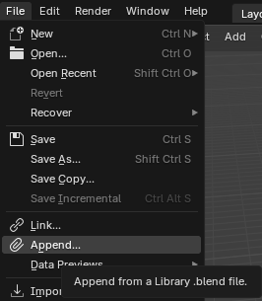
Step 2: Double click the .blend you want to work on, it will take you into more folders which I usually select ‘Collection’ and everything inside that.
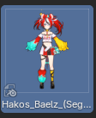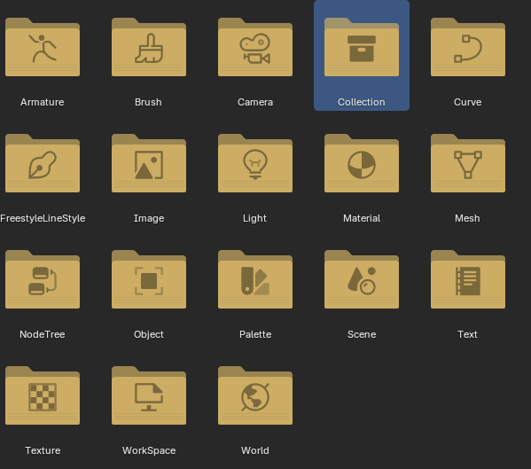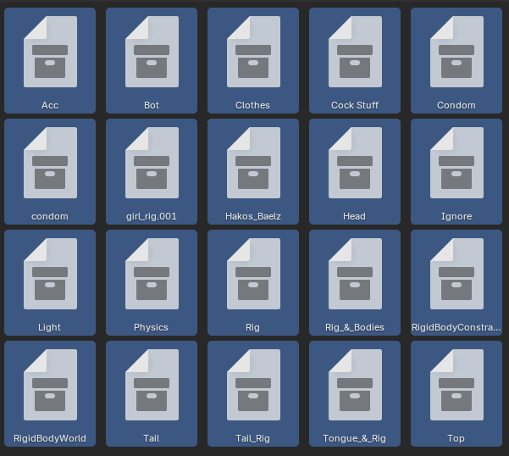

Step 3: Depend on the model they have lots of extra stuff that sizebox do not use. I typically delete stuff like this 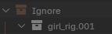 but it can vary from model to model. If you do not want to delete anything you can simply hide it too. Blender does not delete stuff in folder but you can right click and 
Note: in blender you may need to enable the monitor to properly see other parts 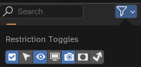
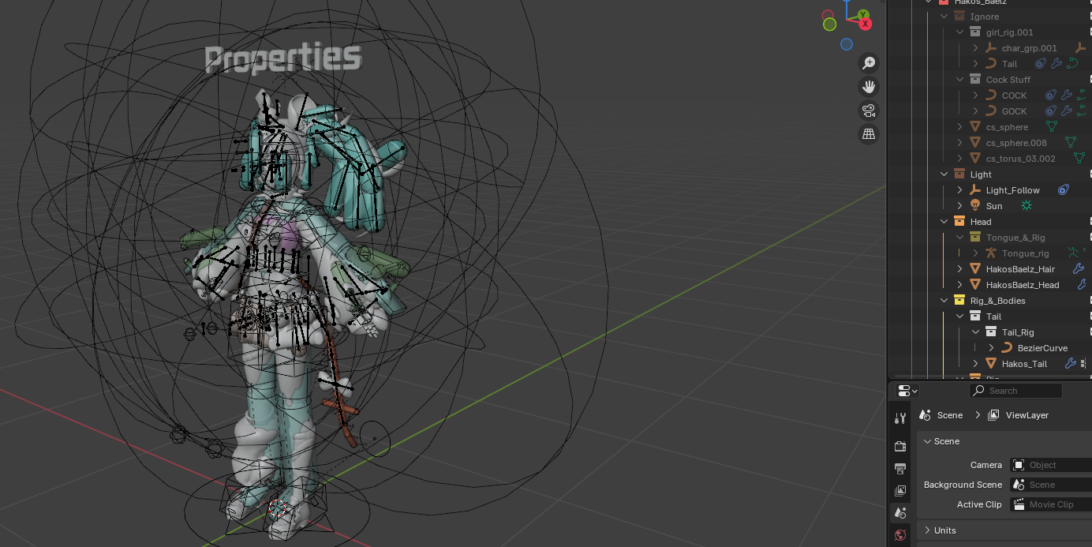
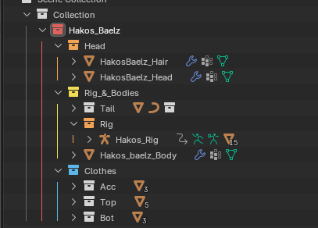This is all the stuff I usually keep. Again it depend on model if you have different body or clothing sets

Step 4: In Object Mode. Select each part with next to it. These are the meshes for that part. Then navigate down to the 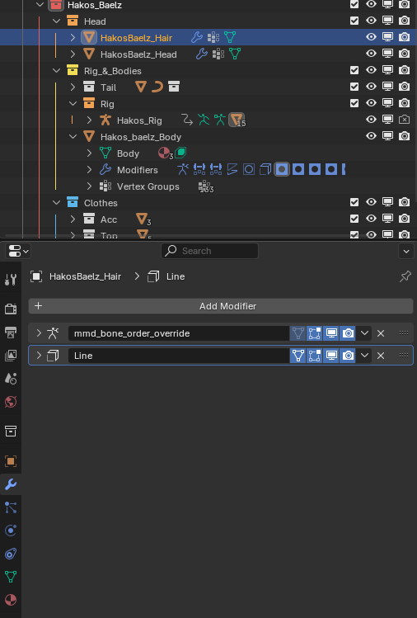 Each mesh will have modifier. Most of the time you do not have to touch these. But I usually delete anything extra like this Line modifier. The shaders in sizebox are different in Blender so we cannot use this modifier properly. The one at the top is the Armature. Do NOT delete this one.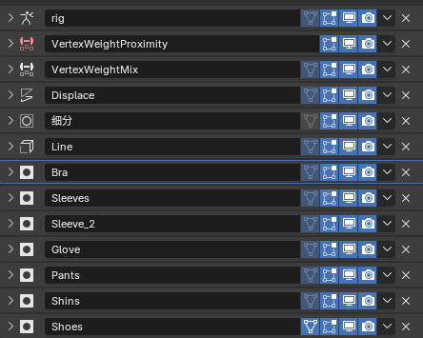
This is the main body mesh with alot of modifier. It has masks to hide body parts that clip through clothing. You can choose to apply these modifier to the mesh, but it will be like deleting that part of the body. You can also remove the mask and use shapekeys to try and hide body parts underneath the clothing. I will not be covering how to make the shapekeys.
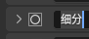This modifier is the Subdivide. It makes the mesh more smooth. Again you can choose to delete or apply the modifier but you may run into problems if it has shapekeys already. There are several plugins that can apply modifier and keep shapekeys.

Step 5: Once you have cleaned up all the modifier go to on each of the meshes to check for shapekeys.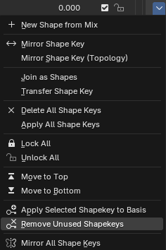 depending on the model you may need to apply this button to clean up some model. Also depending on the model you may need to select “Apply Selected Shapekey to Basis” since some use shapekeys that you do not need.

Step 6: Once You have the model ready to your liking, go to here to get the textures.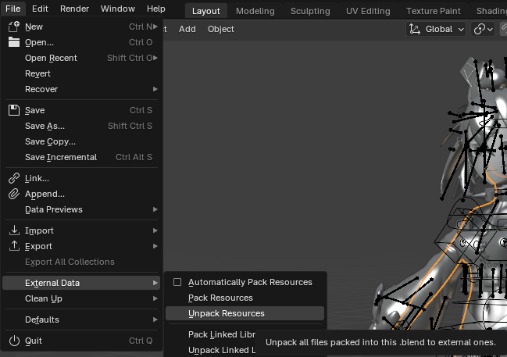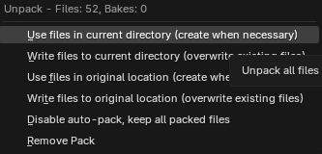This will create a folder called ‘texture’ in the same place you save the blender file. You will need these later when you import to Unity.

Note: I use the default display since more expensive model take a long time to load shaders for blender. If you do not want your blender to freeze, stay in this mode. And avoid going into  for the time being.

Step 7: Export as FBX here. I am using Blender 4.4 which should have default fbx stuff
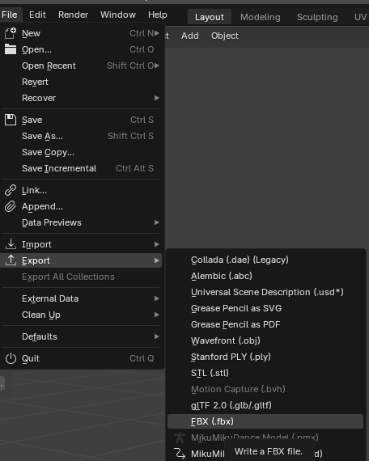
IMPORTANT: Before you export make sure ‘Apply Modifiers’ is off. Otherwise you lose all shapekey for the face and body.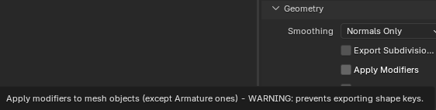
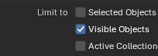you can also select ‘Visible Objects’ when you export so it will only export the rig and body and clothes that you can see. And nothing that is hidden.

Step 8: In a new blender file now you will need a plugin called CATS Blender plugin and MMD tools. There are many different versions that I have tried, so I cannot reliably provide one that will work on different blender versions.
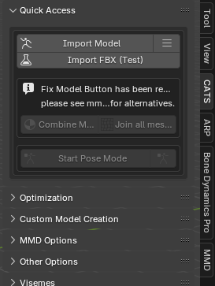 Import the FBX model you just exported.
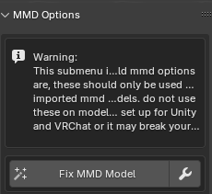Once that is done go to MMD Options and select  and I use these setting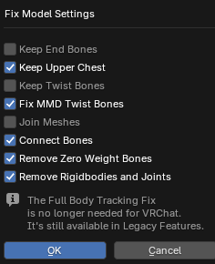 Press OK then Fix MMD Model. 90% of the time this will cleanup the model pretty good. But it can have errors the more complex the model is. In very rare case it does not work at all and you will have to manually fix yourself. Even with the fix button I still have to make very light fixes. Which i will show how to do here. With the Armature selected in Object Mode go to and 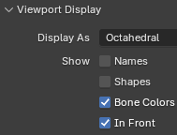check ‘In Front’ and also enable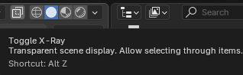 this will make it easier to edit.
Step 9: In the CATS menu 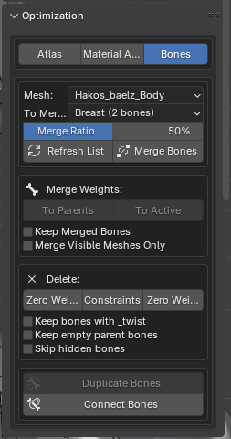Go to Optimization tab and select Bones
Next go from Object Mode to Edit Mode and look for bones that overlap like so.

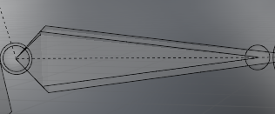You will need to merge these bones by clicking on one and Shift select the one you are merging to. For Example: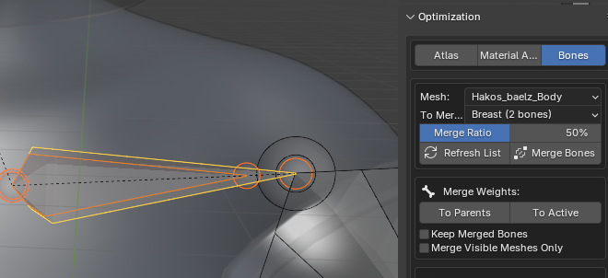The orange one is going to be merged into the yellow one once we select ‘To Active’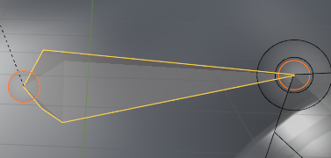The extra bone is gone! MMD has twist bones that you can choose to keep if you want. But sizebox does not have many good use for them from what I have seen. Typically the bones you need to merge are both the arms and legs. Some of the chest and head bones and hand bones. It will vary from model to model. This is probably the most tedious part as you can easily merge something by accident. But you can always undo! You can also go from Edit Mode to Pose Mode, and move the bones around to see which parts of the body the bone controls. I am still experimenting with each bone and I have found that merging most of these is reliable for Sizebox.

Step 10: Depending on how you want your model to work you can choose to skip but I do this to give more freedom with customizing the model. Go back to Object Mode and look for each mesh of the model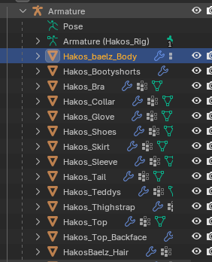 next to the and you should see some listed material 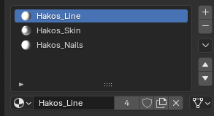 the number indicates how many other meshes share the texture. Since I deleted this line texture I will remove it from each one. In Sizebox, if a material is shared by the same meshes then they will get merged on the conversion. To avoid this you can select which will copy the texture and give you the option to rename it how you like it. This also makes it easier to find when you want to hide certain parts of clothes on a body in Sizebox. For example. 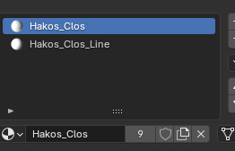These are the shorts mesh for the model. It shares with 9 other meshes.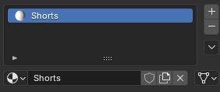I click and rename it how I want so I can easily find it later in Sizebox. Do this for all meshes and textures as you like. Remember we apply the texturing in unity later. Do not worry if the model is all white.

Step 11: If you made it this far congratulation! The hard part is mostly done! Go to Object Mode and select the Armature and do these next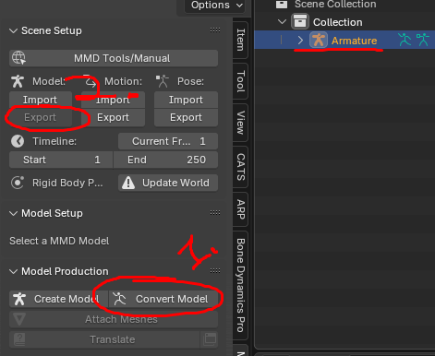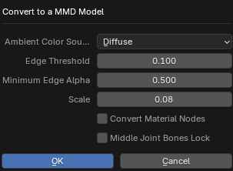Once that is done. Undo to get your Armature back to keep making edits if you need to. After this is it essentially done! If you have problems please feel free to ask me, I will try and write back to you as soon as possible!

My method of exporting from FBX to PMX and then back to FBX is to make sure the bones are orientated the right way for posing in Sizebox. The rest of the method will take place in Unity from the usual Sizebox SDK guide for converting models. Please follow that guide as it covers alot of things very well!

